Class Level Variable OR class Variable
Variables defined inside the class are 2 types
- Instance variables
- Class level variables

Inside the class instance variables bind with “self”. Instance variables are accessible or manipulated only inside instance method.

The variables declared inside the class and outside the methods of the class are called class level variables.
These variables bind with class name and can be accessible without creating object.
Class level variables are global variables, which are global to more than one object.
Class level variables define the common property, which is common for more than one object.

Syntax:
class class-name:
class-variable-name=value
class-variable-name=value
def __init__(self):
self.instance-variable=value
self.instance-variable=value

Example:
class A:
x=100 #class level variable
def __init__(self):
self.y=200 #instance variable

print(A.x)
obj1=A()
print(obj1.y)

Output
100
200

Class level variables memory is allocated only once. The variable value is shared by all the objects.

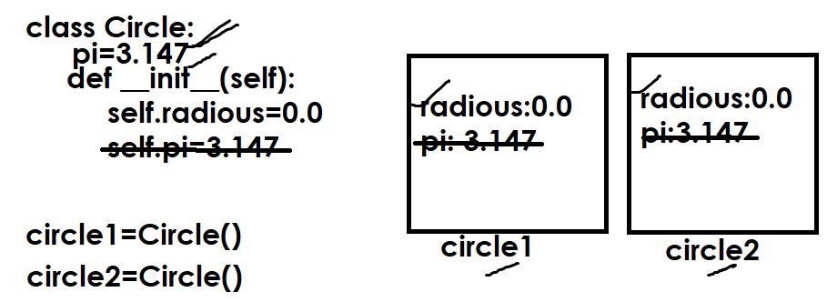

class Circle:
pi=3.14
def __init__(self,r):
self.__radious=r
def findArea(self):
area=Circle.pi*self.__radious*self.__radious
return area

circle1=Circle(1.5)
circle2=Circle(2.4)
area1=circle1.findArea()
area2=circle2.findArea()
print(f'Area of circle1 is {area1:.2f}')
print(f'Area of circle2 is {area2:.2f}')

Output
Area of circle1 is 7.06
Area of circle2 is 18.09

Example:
class Account:
min_balance=5000
def __init__(self,a,cn,b):
self.__accno=a
self.__cname=cn
self.__balance=b
def printAccount(self):
print(f'AccountNo {self.__accno}')
print(f'CustomerName {self.__cname}')
print(f'Balance {self.__balance}')
def deposit(self,t):
self.__balance+=t
def withdraw(self,t):
if t>(self.__balance-Account.min_balance):
print("Insuff Balance")
else:
self.__balance-=t

acc1=Account(101,"suresh",45000)
acc2=Account(102,"ramesh",55000)
acc1.printAccount()
acc2.printAccount()
acc1.deposit(10000)
acc2.withdraw(20000)
acc1.printAccount()
acc2.printAccount()

Output
AccountNo 101
CustomerName suresh
Balance 45000
AccountNo 102
CustomerName ramesh
Balance 55000
AccountNo 101
CustomerName suresh
Balance 55000
AccountNo 102
CustomerName ramesh
Balance 35000

Class level method
A method defined inside class with first parameter “cls” is called class level method. This method is bind with class name and can be called without creating object.
Class level method is used to manipulate class level variable.
Class level method is defined with @classmethod decorator.

Syntax:
class class-name:
class-level-variable-name=value
class-level-variable-name=value
@classmethod
def method-name(cls,param1,param2,param3,..):
statement-1
statement-2

def __init__(self):
self.instance-variable-name=value
self.instance-variable-name=value
self.instance-variable-name=value
def instance-method-name(self,..):
statement-1
statement-2

Example:
class A:
@classmethod
def m1(cls):
print("class method")
def m2(self):
print("instance method")

A.m1()
obj1=A()
obj1.m2()

Output
class method
instance method

Example:
# Count of objects created using class

class Employee:
__count=0
@classmethod
def getCount(cls):
return Employee.__count
def __init__(self):
Employee.__count+=1

print(Employee.getCount())
emp1=Employee()
print(Employee.getCount())
emp2=Employee()
print(Employee.getCount())

Output
0
1
2

Example:
# class method cannot access instance variables

class A:
def __init__(self):
self.__x=100
@classmethod
def printX(cls):
print(self.__x)

A.printX()

Output
Error

The above code generates an error because of class method access only class level members but cannot access object level members.

What is difference between instance method and class method?

Instance methods | Class level methods
A method defined inside class with first parameter “self” is called instance method | A method defined inside class with first parameter “cls” is called class method and this method defined with @classmethod decorator
Instance method is called or bind with object name and can be called by creating object | Class method is bind with class name can be called without creating object.
Instance method access instance members and class members. | Class method is able to access only class members but cannot access instance members

Static method
A method defined within class without implicit first parameter is called static method. This method is defined with @staticmethod decorator.

Syntax:
class class-name:
class-variable-name=value
class-variable-name=value
@classmethod
def class-method-name(cls):
statement-1
statement-2
def __init__(self):
self.instance-variable-name=value
self.instance-variable-name=value
def instance-method(self):
statement-1
statement-2
@staticmethod
def static-method-name():
statement-1
statement-2

static method is bind with class name and can be invoked without creating object.

class A:
x=100 # class level variable
@classmethod
def c1(cls):
print(cls.x)
def __init__(self):
self.y=200
def m1(self):
print(self.y)
@staticmethod
def sm1():
print("static method")

A.c1()
A.sm1()
obj1=A()
obj1.m1()

Output
100
static method
200

Example:
class Math:
@staticmethod
def factorial(num):
fact=1
for i in range(1,num+1):
fact=fact*i
return fact
@staticmethod
def isprime(num):
c=0
for i in range(1,num+1):
if num%i==0:
c=c+1
return c==2

res1=Math.factorial(4)
res2=Math.isprime(5)
print(res1)
print(res2)

Output
24
True

Inheritance
Inheritance is a process of acquiring the properties and behavior of one class inside another class.
Inheritance is process of using the content (variables and methods) of one class inside another class.
Inheritance allows developing new data type using existing data type.
Inheritance allows grouping all the classes which share common properties and behavior into one type.

Advantage of inheritance
- Reusability
- Extensibility
- Modularity

Reusability: This allows to use the variables and methods of one class inside another class.
Extensibility: This allows to extend the functionality or features of existing class without modifying it
Modularity: allows dividing content into number of classes.

